**Objective**

In this challenge, we lay out buttons inside a *div* and modify their labels after each click event on one of the buttons. Check out the attached tutorial for learning materials.

**Task**  
We want to create nine buttons enclosed in a *div*, laid out so they form a **3x3** grid. Each button has a distinct label from **1** to **9,** and the labels on the outer buttons must rotate in the *clockwise* direction each time we click the middle button.

Complete the code in the editor so that it satisfies the following criteria:

* *Initial State.* The initial layout looks like this

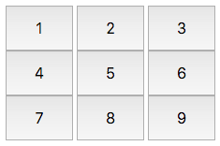

*Element IDs.* Each element in the document must have an id, specified below:

* The button container *div*'s id must be btns.
* The initial innerHTML labels must have the following button ids:

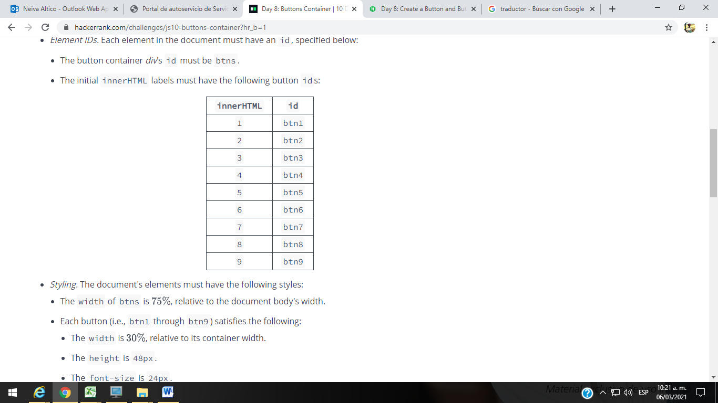

* *Styling.* The document's elements must have the following styles:
  + The width of btns is , relative to the document body's width.
  + Each button (i.e., btn1 through btn9) satisfies the following:
    - The width is , relative to its container width.
    - The height is 48px.
    - The font-size is 24px.
* *Behavior.* Each time btn5 is clicked, the innerHTML text on the grid's outer buttons (i.e., bt1, btn2, btn3, btn4, btn6, btn7, btn8, btn9) must rotate in the *clockwise* direction. *Do not* update the button id's.

The .js and .css files are in different directories, so use the *link* tag to provide the CSS file path and the *script* tag to provide the JS file path:

<!DOCTYPE html>

<html>

<head>

<link rel="stylesheet" href="css/buttonsGrid.css" type="text/css">

</head>

<body>

<script src="js/buttonsGrid.js" type="text/javascript"></script>

</body>

</html>

**Explanation**

Initially, the buttons look like this:



fter clicking btn5  time, they look like this:

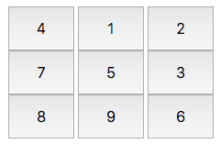

After clicking btn5  more time (for a total of  clicks), they look like this:

